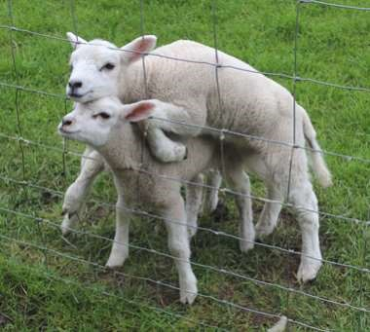

The Newsletter for Middleton on the Wolds

Issue No 35

MARCH 2022

NEXT COPY DATE

14th March

Please send in your contributions to middletonflyer@yahoo.com by the end of the copy day. If I don’t acknowledge them please get in touch to make sure they have arrived.

Size Matters
Please be aware when sending in posters or advertisements that a standard A4 page has to be reduced to half the size to fit onto a Messenger A5 page . Unless
you want readers to have to reach for a magnifying glass, please make sure that the font is large enough for the reduction eg Times New Roman 16 point reduces to the size of the font you are reading.
Lyn
4 The Paddocks 219500

ADVERTISING COSTS for the Messenger

Rates Month Year
Whole Page £25 £150
1/2 Page £15 £100
1/3 Page £10 £60

Full colour - Print run 500 copies
Contact: Tina 01377 217242, middletonflyer@yahoo.com
The cute front cover picture was taken by Tina Walker last spring.

Editorial
There are articles in this month’s edition about the proposed Platinum Jubilee celebrations in June. Whether or not you agree with the reason, at least it gives us the
excuse to party! As well as the events already organised there is also the potential to hold street parties and the like. It might be a little awkward putting tables up on Front Street but there are other places where we could get together as a community, either as a whole village or as just a collection of houses. It’s your choice.
So, lockdown is virtually over. We now know that we no longer have to wear face masks in public places. I suppose the numbers will show whether or not this is a ‘good thing’ but, in the meantime, we should remember that this is only advice. Some people still feel more comfortable wearing a mask and maintaining social distancing and we should respect that. Similarly, some shops are still insisting that we wear a mask if we want to enter. ‘Ah!’, I hear you cry, ‘Boris says I don’t have to wear a mask anymore. This is an infringement of my personal freedom!’ Well, if you think this is an attack on your personal freedoms maybe you should consider the personal freedoms of the people working in those shops. They have to be there; you don’t. It’s all about recognising where you are and acting appropriately – and responsibly.
Finally, I’ve had our first takeaway from Wolds Pizza. Very nice; very nice indeed. I think it will be a great amenity for the village.
Stay safe.

Mike

P.S. My mole is proving to be a cunning little beggar, but I hope to have ‘resolved the situation’ soon!

If you have any ideas, comments or complaints (especially complaints) you want to share then send an email to middletonflyer@yahoo.com.
Remember, we can’t respond unless we receive your message.

QUIZ PAGE
Which island in the English channel first held its annual music festival in 1 1968?
Earth and what other planet in our solar system have names beginning
- with a vowel?
- Who was the US president at the start of the American civil war?
- What number is both the cube of 4 and the square of 8?
Complete the name of the 1941 film starring Ginger Rogers, Tom Dick
- and ?
Famously worn by punks what fastening device was invented by Walter 6
Hunt?
- What American city is dubbed the biggest little city in the world?
- Ninian park is the former ground of which football club?
- What is the fourth Greek alphabet letter?
- What is the name of the tendon connecting the heel bone to the calf?
Quiz set by Rowland Wooldridge
All answers on page 21
DINGBATS
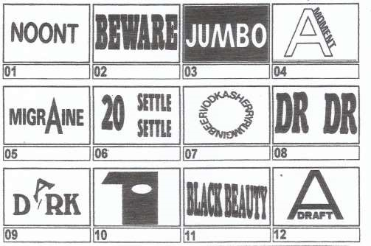
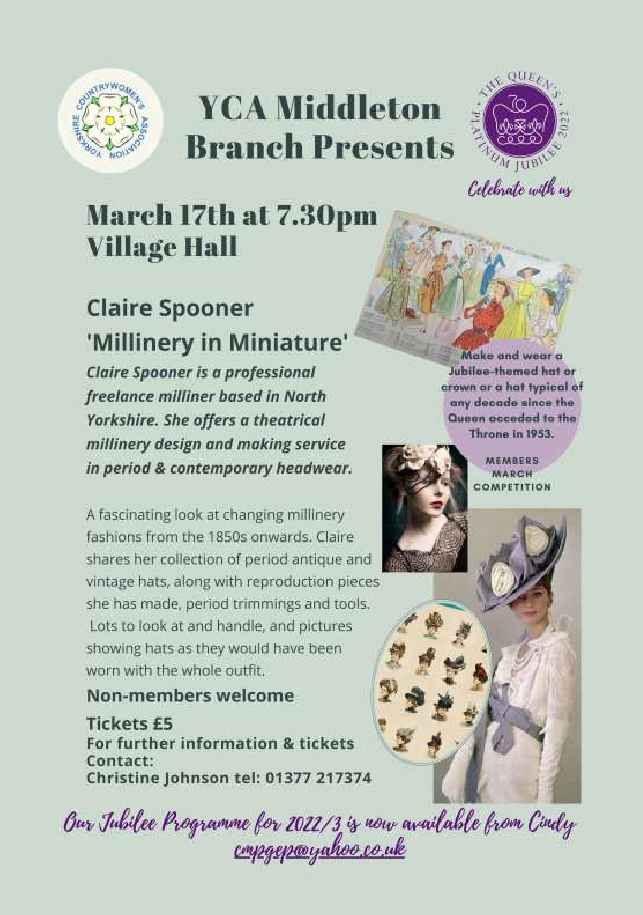

a note from your vicar

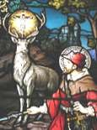
March – A Woolie Wonder
In the field next to the Rectory we have new neighbours – sheep, which will be joined in a couple of months by their fluffy little offspring. It is lovely to see the lambs chasing each other and the amazing ability they have to find their mum just by the sound of her voice. Sheep and shepherds have their very own Saint – Walstan, he was an Anglo-Saxon nobleman who renounced his wealth and became a farmhand – working on the same farm for 30
years in Bawburgh, Norfolk.
Thinking about sheep led me to look up this well-known children’s poem:
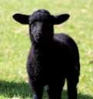
Baa, baa, black sheep, have you any wool?
Yes, sir, yes, sir, three bags full;
one for the master,
one for the dame,
and one for the little boy
who lives down the lane.

It turns out there is an interesting and historic background to this nursery rhyme. The version we all grew up with has been altered from the original – the last line was ‘And none for the little boy who cries down the lane.’
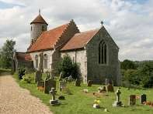
Sheep have been very valuable to the English economy for well over 1000 years. The Domesday Book tells us that many flocks across the country were over 2000 strong and by the 13th Century there could be as many as 8,000 in a flock tended by a dozen full time shepherds. English wool was considered to be the finest in the world. There are still magnificent Wool Churches in this country – often found in small villages, which were built during these glory days.

With the growing number of traders and exporters a great deal of money flowed into England. This meant that King Edward I was able to impose new taxes on the exports of wool to fund military campaigns and his treasury. This included a royal tax of six shillings and eight pence per wool sack – a third of the price of each sack. It was this ‘wool tax’ that is said to be the subject of ‘Baa, Baa, Black Sheep’
St Andrew’S church

Services for March

Sunday 6th 10.30am Morning Prayers. C/W
Sunday 13th 10.30am Holy Communion. Rev`d Jane Anderson
Sunday 20th 10.30am Holy Communion. Rev`d Cannon Kate Goulder Sunday 27th. 10.30am Holy Communion. Rev`d Ruth Newton

The wolds METHODIST CHURCH

Services for March
Sunday 6th 10.30am | Service at the Wolds Methodist Church,
 | Mrs Irene McGowan
Sunday 13th 10.30am | Service at the Wolds Methodist Church,
 | Mr Stephen Byass
Sunday 20th 10.30am | Service at the Wolds Methodist Church,
 | Miss Margaret Collinson
Sunday 27th 9.00am | Mothering Sunday Café-style Service with
 | Breakfast at the Wolds Methodist Church,
 | Rev Dr Richard Teal
One third of the price of each sack must go to the king = ‘the master’ Two thirds to the Church or monasteries who owned much of the land the sheep were grazed upon = ‘the dame’ and none for the actual shepherd = ‘the little boy who cries in the lane.’

Rather than being a sweet little rhyme that teaches children animal sounds and how to share things in a fair way, it is a sadly all too familiar commentary on the inequality and unjust state of affairs that hard- working people have to contend with to this day. (In 2021 the average price per kg of wool was 32p) Maybe we need a bit of assistance from St Walston!

Jane
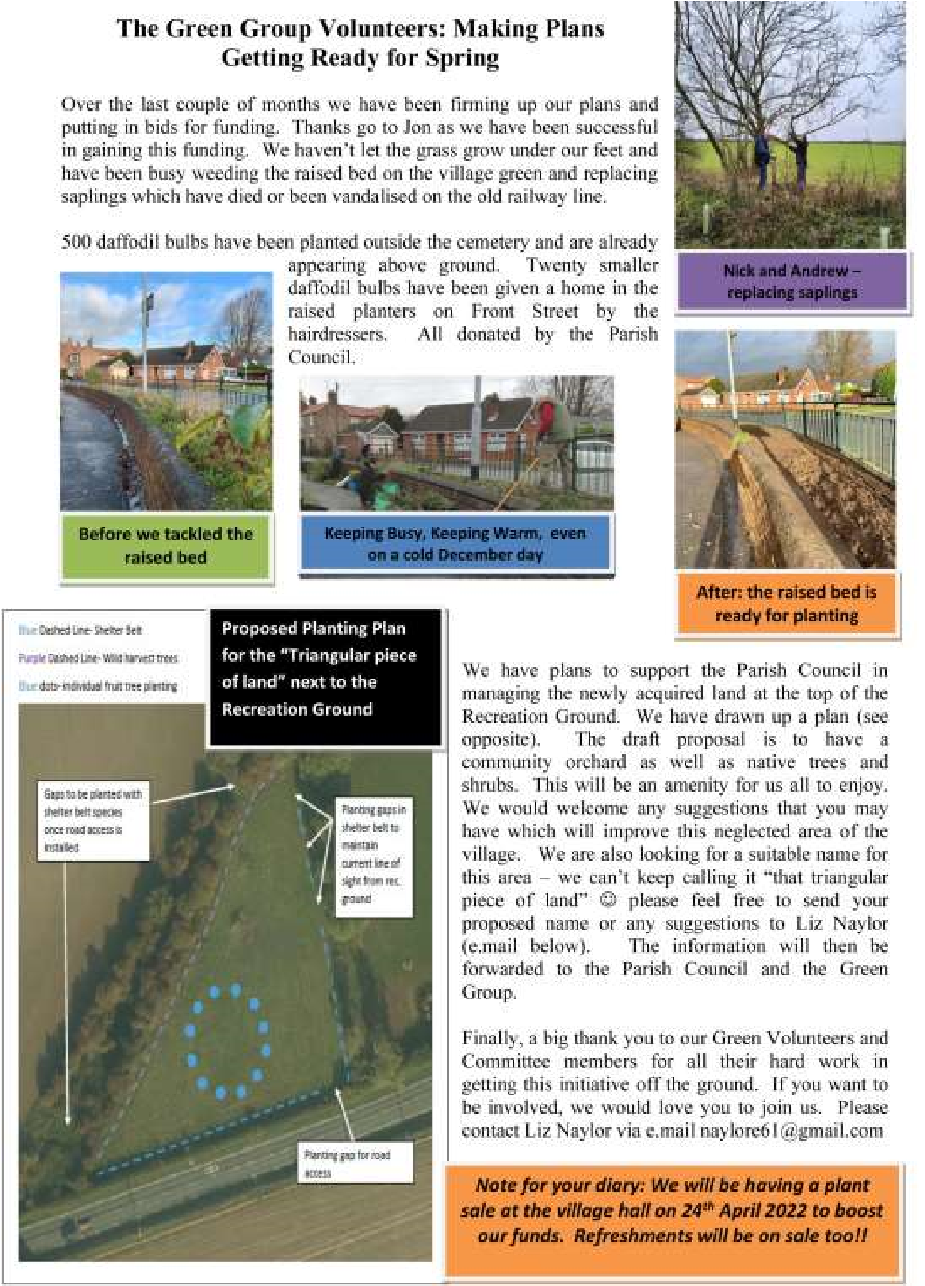

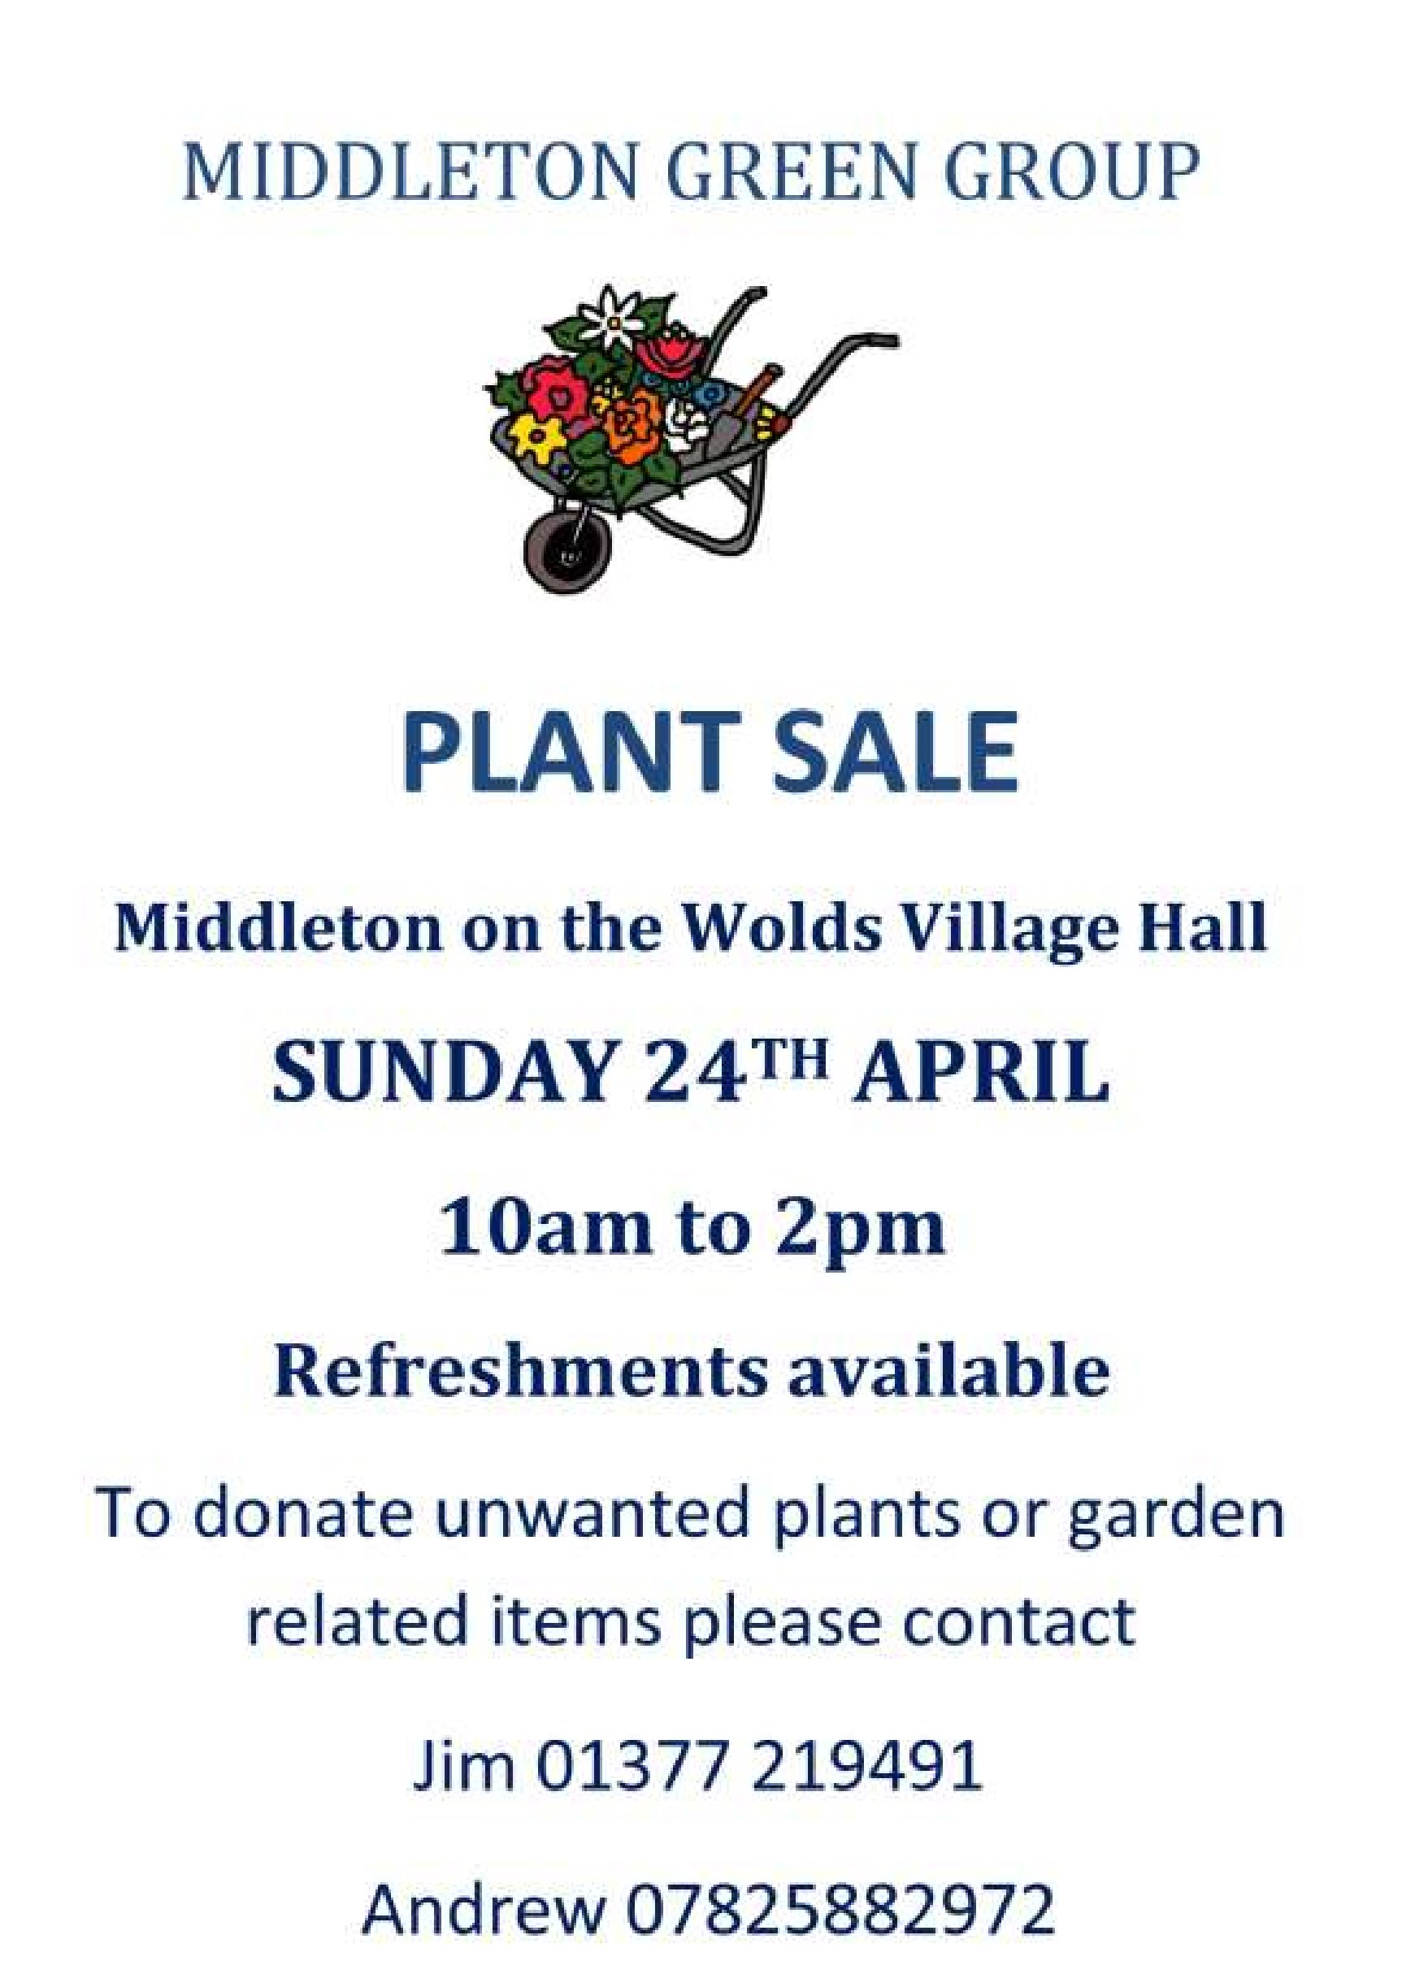

Middleton and north Dalton cricket club

About us:
The 2022 cricket season begins in April and we are really looking forward to another enjoyable summer of cricket. We have enjoyed great success in recent years; winning several cup finals and local league titles but as always, we are looking for new members and players. Irrespective of experience or ability we would love to see you get involved.
We have a number of different teams playing in a range of league and cup competitions including:
- Two Saturday XIs playing in the York and District Senior Cricket League
- Two Thursday evening XIs playing in Bridlington and District Cricket League
- The National Village Cup XI

Practice sessions:
- Our indoor nets begin on 6th March 2022. Sessions cost just £2. Nets will take place on 6th, 13th, 20th and 27th March 2022 3pm-4:30pm.
- Two additional outdoor sessions will be held at Driffield Cricket Club on Thursday 31st March and Thursday 7th April at 5:30.
- Weather permitting further sessions will be held at Middleton Rec Club in April.
- If you are interested in joining us or just want to find out more then please contact:

Dave Newlove (Club secretary): 07901833784
Tom Walgate (Club Chairman): 07595537219

Junior Cricket
We are hoping to offer junior cricket for the first time this summer. All-stars (5-8 years) and Dynamos (8-11 years) sessions are for both boys and girls and will be taking place on Monday evenings in June and July. The courses last 8 weeks and all sessions will be run by ECB approved trained activators and will offer all participants a fantastic introduction to the game of cricket! Each child will also receive a goodie bag containing a New Balance personalised shirt. Alongside the personalised shirt, All-Stars participants will also receive a free bat and ball and backpack.

The cost of the course is £30. For more details or to secure a place please contact Tom Walgate (Club Chairman): 07595537219.

Golf Day Fundraiser 2022
Our 9th annual fundraising golf day will take place on Friday 3rd June 2022 at The Oaks Golf Club and Spa. It is a fourball format with prizes for the winning team. The fees are £40pp including bacon sandwiches with coffee on arrival, 18 holes of golf and a two-course meal after your round. Tee times will be available throughout the afternoon. The success of the day heavily relies on generous sponsorship; if you would like to sponsor a hole or book a team slot then please contact Dave Brent (07788 985745) or Mike Anderson (07809 123541) for further information.

Here’s to a fantastic summer of sport!

Village hall news
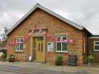
Upcoming Events
Books and Jigsaws will be on sale at the Easter
Fair on Saturday 9th April so if you have any you would like to donate please give them to one of the committee but do also come along to see what bargains you can find.
The Village Hall committee will be selling refreshments at the Green Group’s Plant Sale in the hall on 24th April. Please contact Jim (219491) or Andrew (07825 882972) if you have plants to donate.
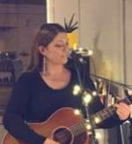
Tickets are on sale now for An Evening with
Edwina Hayes which is on Friday of the Jubilee Weekend. Edwina's beautifully written songs, charming stage presence and voice of an angel have won her a reputation as a true natural talent of gentle folk-Americana. She has opened numerous shows for Jools Holland and Van Morrison as well as her own gigs playing stages everywhere from
Glastonbury Festival to The Royal Albert Hall.

Edwina has a large local following so don’t delay in
buying your tickets from Sharon on sroe.general@gmail.com / 217254 or from any of the committee members. (poster overleaf).

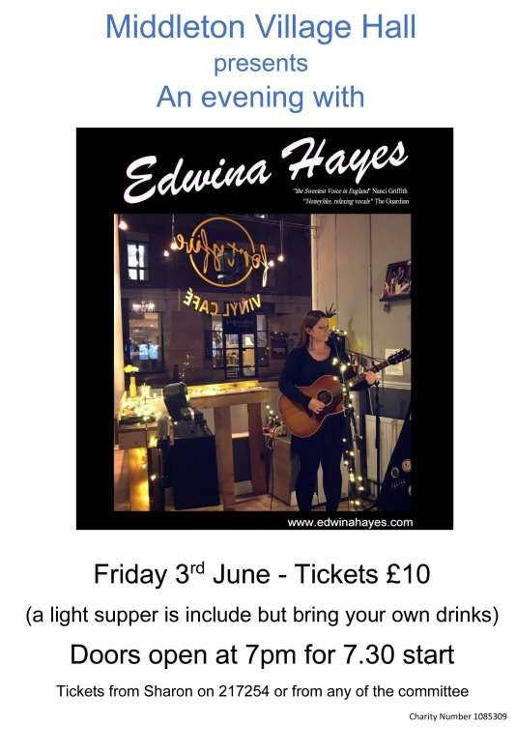

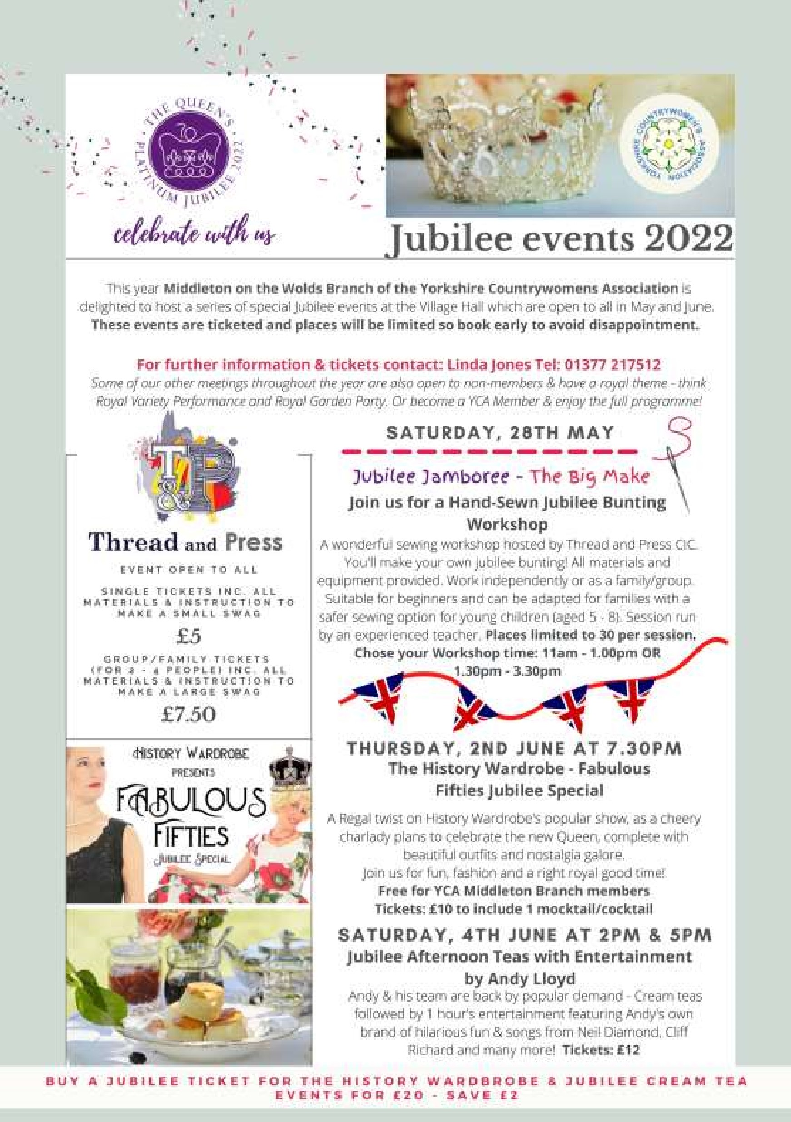

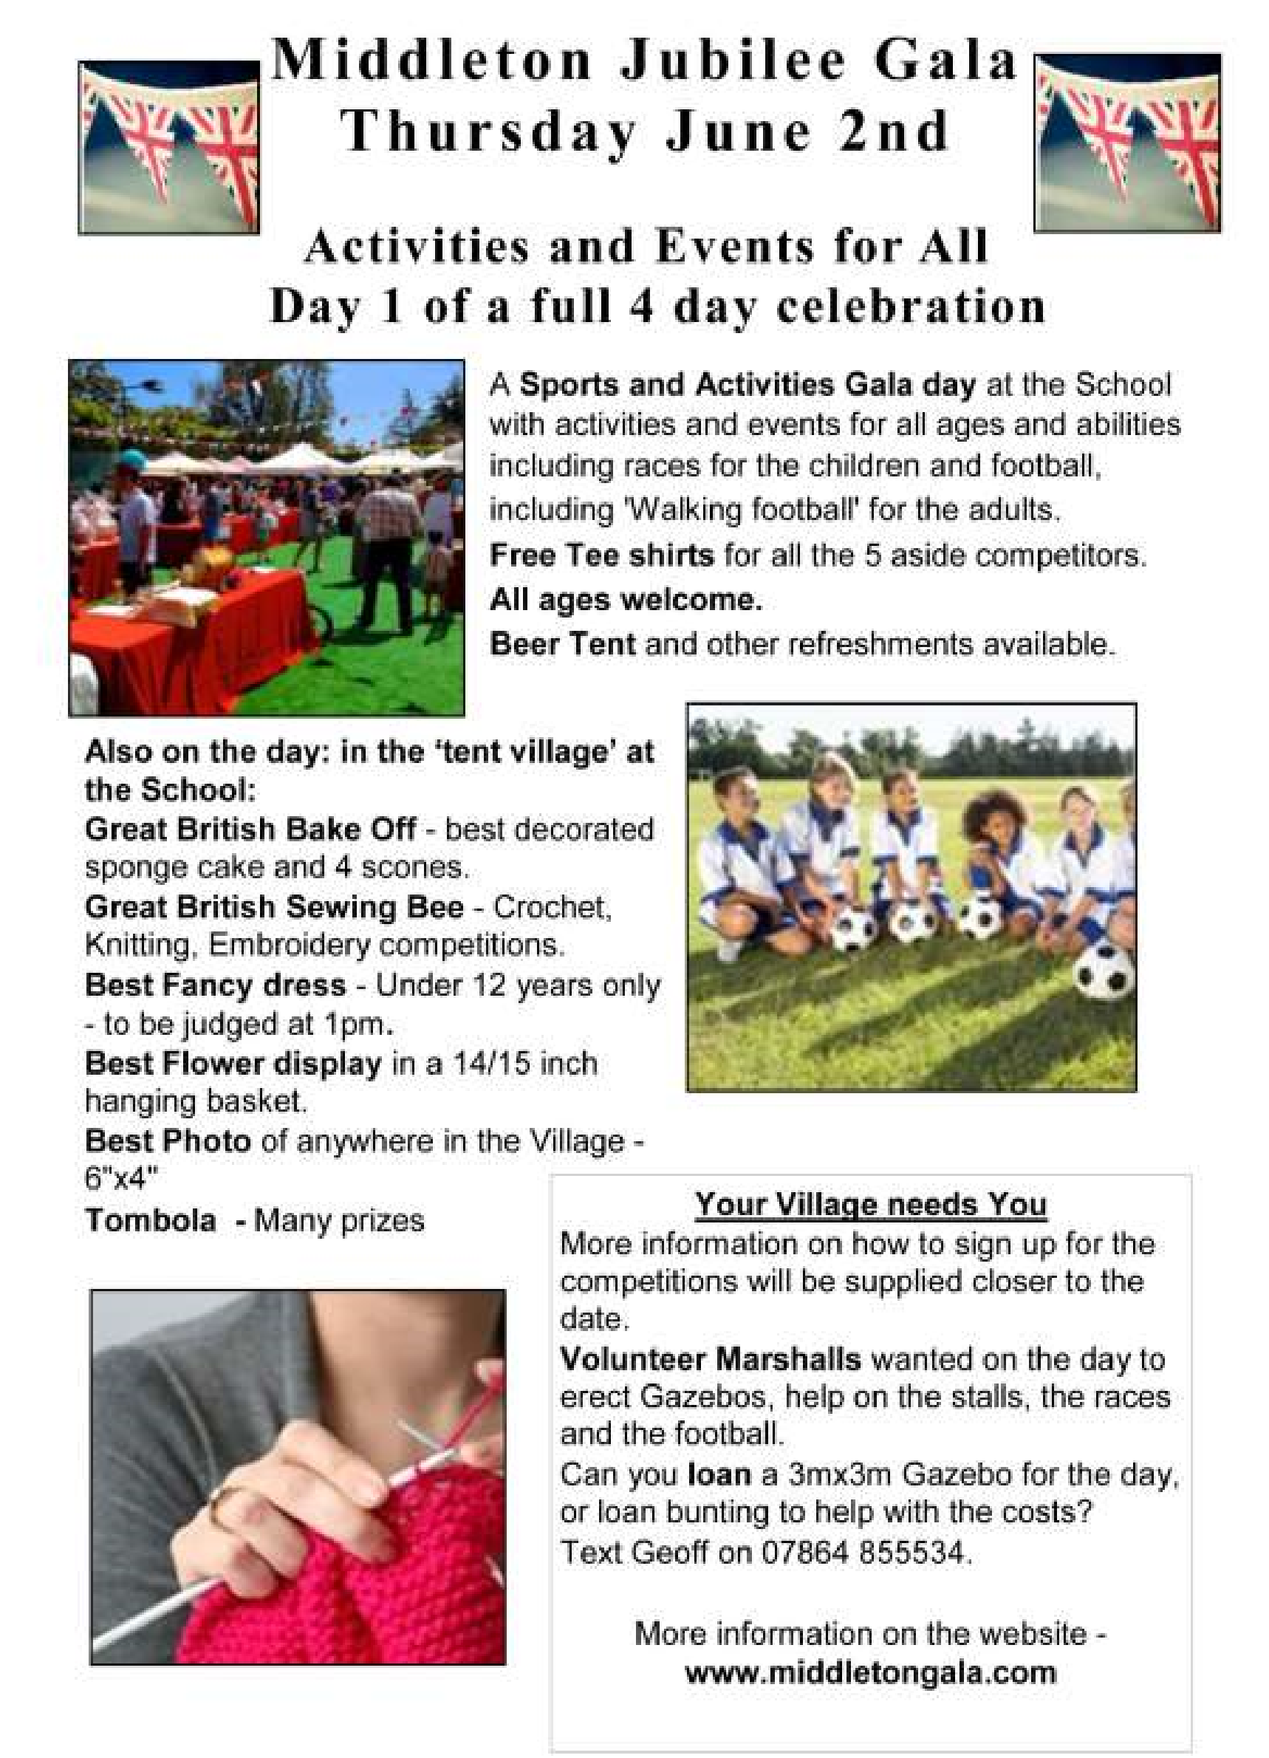

LOCAL HISTORY

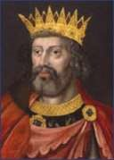
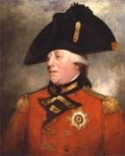
ROYAL JUBILEES
There had been monarchs in the past who had reigned for fifty years or more such as Henry the third (1216-72) and Edward the third (1327-1377) but we have no knowledge of any local celebration of their staying power in kingship. In the case of George the third however there is a rare book by the wife of a naval officer in which local festivities are referred to in Wansford, Beverley,
Bridlington and Hunmanby: a common feature seems to
have been beef, beer and the firing of
volleys together with grand dinners _{Henry III} for the local bigwigs.
George the third was a man of wide interests with a particular concern about agriculture thereby earning himself the nickname of “Farmer George” and his long reign from 1760 to 1820 in which he had to overcome his political disappointments earned him the reputation for domestic virtue which ended in 1811 with his mental
breakdown. In the interim his son, the future George the fourth acted as Regent. A leader of fashion in Edward III his early days he came to the throne in 1820 but ended his reign
in 1830 as dissolute, spendthrift and a bloated enemy of political reform gaining him on his death a resounding vote of disapproval from The Times newspaper: “Never was there a human being less respected than the late king....what eye weeps for him.” If George’s coronation ceremony could be described as profligate that of his brother William, a naval officer of modest achievement, was cut price while Victoria
the only child of George the third’s fourth son who had ^{George III} come to the throne when there was scant respect for the monarchy suffered from under rehearsal which was a less than auspicious start for a woman who would give her name nationally and internationally to an age and become known as the “Grandmother of Europe”
In Middleton Victoria’s Coronation was celebrated and the Hull Packet of the 6th July 1838 Reported:
“Middleton and Lund”
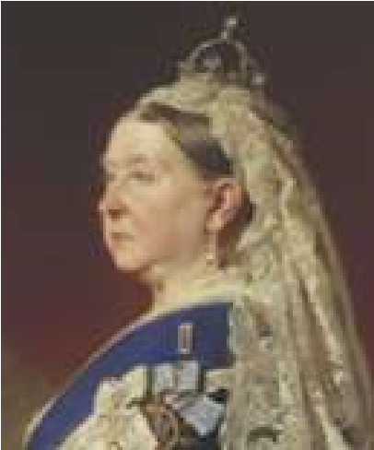
“The loyalty and good feeling which have been so universally displayed on the celebration of the day set apart for the coronation of Her Majesty, were exhibited in no small degree in these parishes, £14 have been subscribed at Middleton and £6 in the adjoining parish of Lund; the labourers were regaled with dinner and to their wives with tea. 220 children having previously received medals, sat down to tea in front of the house of the Rev. John Blanchard, the rector at Middleton and nearly the whole population went afterwards to witness the
gratifying scene. Nothing could exceed the attention of Victoria the worthy rector and his lady, who exerted themselves to the utmost in promoting the comfort and hilarity of the juvenile party; few of whom will ever forget the liberal entertainment provided for them or the auspicious occasion which called it forth.” £1 would then have had the approximate spending power in today’s money of £100. Do any of the medals survive, tucked away and forgotten in some attic?
Victoria, who had married in an elaborate ceremony followed by a sumptuous breakfast, Albert a high minded, industrious, misunderstood German prince; produced a large family; and was devastated on her husband’s early death in 1861 subsequently entering an extended period of mourning with minimum performance of public duties: a situation which in the 1870s called forth a demand in certain quarters for the abolition of the monarchy and the creation of a republic. Her favourite prime minister, Disraeli, came to the rescue in 1877 by creating her Empress of India and by her golden jubilee in 1887 faith in the monarchy had been restored.
There were widespread local celebrations for the jubilee with North Dalton and Bainton receiving a mention in the local press but if Middleton rejoiced it did not appear to have been reported; however the Beverley Guardian stated that the Jubilee arrangements in the “Wolds Villages” were of a spirited character.”
The Diamond Jubilee in 1897 was celebrated nationally with greater enthusiasm than 1887 but in Driffield less so because there was disagreement on what form the permanent commemoration of the event should take. In Middleton the sudden death of Wilsh Crowe, a local worthy, cast a gloom over the village’s festivities according to the Driffield Times. That newspaper helpfully published a special illustrated supplement entitled “Queen’s Record Reign, a bird’s eye view of the Commerce, Science, Art and Literature of Sixty years.”
The Beverley Guardian however did publish a report: “Middleton-on-theWolds; On Sunday there were services and hymns in the parish church for the 60th anniversary of the Queen’s Accession. Collections of £3 were made for the Victoria Sustentation Fund. On Tuesday the church bell ringers rang several times during the day, beginning at 6.30 in the morning, of their own free will. The parishioners had kindly subscribed about £30 which was expended on an excellent tea for more than 500 parishioners, in addition to provisions sent to about 20 who could not come in person, and in 22 kinds of sports for children in the afternoon and adults in the evening. The prizes were given by Mrs Wood about 9.50pm.”
In January 1901 the Driffield Times reported “ The long, glorious and benevolent reign of Queen Victoria came to a close at half past six on Tuesday evening,” The same newspaper had a report a few days later about a much humbler character:
“Middleton, Living in five reigns - There is at present living in this village, an old labourer named James Gell who has lived under five British monarchs and who remembers the death of George III. Gell, who was 25 years of age when the Queen was crowned, has brought up a family of nearly a dozen children and at present lives on a little of the money he has saved. He is 89 years of age and still occasionally does a day’s work.” Mr Gell who lived at Wold Cottages died in 1903.
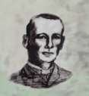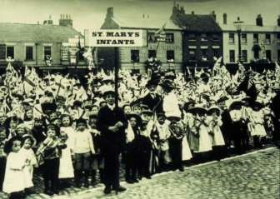
Geoff Wisher

A correction to last month
’
s Local History Feature

The Rev Morris referred to in the article who
described the life of a farm girl was Rev Marmaduke
C F Morris not Rev Francis Orpen Morris (his father)
whose picture attached to the article.

Apologies for the confusion.

Lyn

Rev Marmaduke C F Morris

Saturday Market,
Beverley pupils from St
Mary
’
s School
celebrating Queen
Victoria's Diamond
Jubilee 1899

Middleton book group
This month we not only ventured to Kirkburn village Hall but each member contributed by reading poems that appealed to them. There was a great variety of subjects and authors. A poem by Philip Larkin about a country show made us think about Driffield Show . Two others chose poems about horses. One by Ted Hughes and another about horses going to war. Another poem by Ted Hughes was chosen. It was called Flounders and not many knew it. John Betjeman also entertained us with one of his less well-known poems Agricultural Caress.

This meeting proved a success and I would recommend any of the poems mentioned.

Judy

One of the poems is particularly apt for a book group:
I opened a book and in I strode.
Now nobody can find me.
I’ve left my chair, my house, my road, My town and my world behind me.
I’m wearing the cloak, I’ve slipped on the ring, I’ve swallowed the magic potion.
I’ve fought with a dragon, dined with a king And dived in a bottomless ocean.
I opened a book and made some friends.
I shared their tears and laughter
And followed their road with its bumps and bends To the happily ever after.
I finished my book and out I came.
The cloak can no longer hide me. My chair and my house are just the same, But I have a book inside me.
Julia Donaldson

Meetings are on the second Tuesday in the month. In normal times we meet in member’s homes but in these COVID times we are using village halls.
To find out more about the Book Group please contact Lyn on 219500 or lyndennis456@gmail.com

The next books for discussion are: Flappy Entertains by Santa Montefiore
Inheritance by Jenny Éclair

Local Birds & wildlife
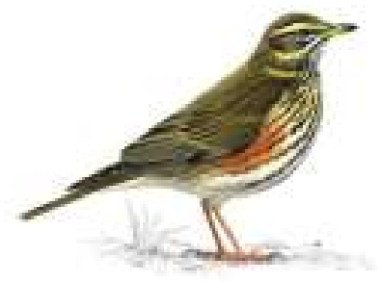
It’s beginning to feel a bit like Spring now, if I ignore the amber and yellow weather warnings for gales this week. The great tits are trying out their summery voices
- “Teacher, teacher!” as their calls have been described
- and any time now there will be robins beating each Redwing other up as they vie for territory.
There are more birds back in the garden; Hazel has five bullfinches regularly meeting up for bathing sessions together in her pond, and we have our longtailed tits back (and an unwelcome rat, but I won’t mention that). The nights are still sometimes cold of course, and several times I have been surprised
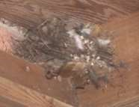
when putting rubbish in the bins under our carport by something whizzing past just above my head. On investigating in daylight I have found that a wren has built up a collection of dead leaves and old feathers, in a corner under the roof, in which it is snuggling down when it needs a cosy bed. It isn’t very neat like a proper nest would be, but so long as it does the job that is all that matters. So no more putting rubbish out after dark in the early evenings!
In what I would imagine is a rather more dramatic bed-time, in Pat’s garden: “A beautiful cock pheasant has just gone up to roost in one of our huge conifers. Never had that before. Hopefully he stays there for the night.” It was back again a couple of nights later, so perhaps will hang around for a bit. And lastly, I saw a redwing splashing around in the bird bath and then hopping up the path to the little pond to have another good splash there. A
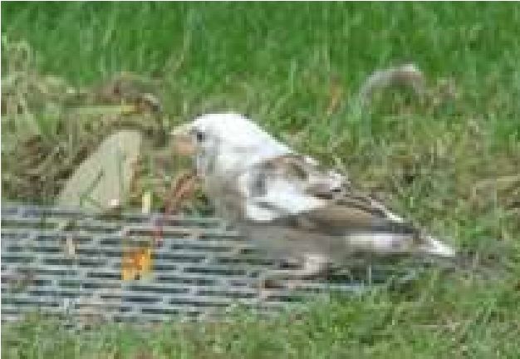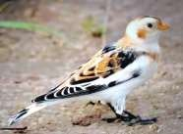
rare treat!

Tension has been building in the village (you must have felt it!) as the Great
Leucistic Sparrow Controversy debate unfolded. I sent our photo to Bill Teale, who writes the Birds column in the Yorkshire Post, and he very kindly replied saying “Yes, it is a lovely male snow bunting. You can see why an old name for them is snowflakes! The females and first winter birds are much browner. They are usually found on the coast but a few do turn up inland. There was a large flock on the Wolds near Wold Newton in 2015.” So I passed this on to everyone who had joined in with the discussion, and also sent a copy of The Messenger to my sister, who is a keen birder, but lives in Sheffield. Our village then split into two factions, those who were really thrilled to think we had a snow bunting, and those who felt the sparrow option was more likely. My sister sent me a link to birdforum.net, where there was a bird identical to ours (which seemed a bit weird) so a friend joined the site as Middletonbirder and posted our photo. Someone replied saying “I’m in Nafferton, and we also have a celebrity leucistic sparrow that pops up on the village FB group every now and again.” And someone else: “Well look at that, there he is! I think that’s the same bird and considering I live in Warter and haven’t seen it since that day” (when he posted his picture as a query) “I’d say there’s a high chance! How cool is that! Thanks for posting, it’s like seeing an old friend!”
So there we are, from mystery to controversy. Is there just one bird in the village or two? Does it flit around between villages? Is there a strange genetic mutation which is spreading throughout East Yorkshire? And what, actually, is it?
You decide!
Please feel free to join in, send me interesting wildlife things or behaviours you’ve seen in your garden (just a description if you don’t have a photo!) and fill up the column with other things if you don’t want to see the word “leucistic” ever again!
Barbara lavenderbarbara97@gmail.com or text on 0777 192 7868
QUIZ ANSWERS

1

The Isle of Wight

2

Uranus

3

Abraham Lincoln

4

64

5

Harry

6

Safety pin

7

Reno

8

Cardiff

9

Delta

10

Achilles

1.

Afternoon Tea

2.

A word of warning

3.

White elephant

4.

A touching moment

5.

A splitting headache

6.

A score to settle

7.

A round of drinks

8.

Paradox (a pair of docs)

9.

A leap in the dark

10.

A hole in one

11.

A dark horse

12.

A large overdraft

Middleton on the wolds ce ve school
Executive Headteacher: Mrs E Harros
Station Road, Middleton on the Wolds, Driffield YO25 9UQ
E-mail:middleton.primary@eastriding.gov.uk Tel: 01377 217323

Middleton Minis
Our parent, carer, baby and toddler group runs from 1:30 to 3:30pm every
Tuesday afternoon (term time only) at Middleton on the Wolds primary school. Drop in for 20 minutes or the full 2 hours. We look forward to seeing you.

On-going Collections
On-going Collections – We collect used stamps and used batteries. Please note we are not currently collecting used printer cartridges or mobile phones until we can source a new company to collect and recycle them.
We have a Bags2School collection booked for 29th April – just after Easter Holidays.

Middleton on the Wolds Nursery
At Middleton on the Wolds CE (VC) Primary School
 Providing education for 2, 3 and 4 year olds Monday - Friday.
 We accept the Government’s childcare vouchers for up to 30 hours of free provision for 3 year olds (conditions apply)
 Additional sessions can be purchased for £13.50 per session for 3 year olds and £15.75 for 2 year olds.
 Lunchtime sessions are £1.75 (free if children attend for the whole day) with the option to purchase a school meal for £2.40.
 Children are welcome in the term after their 3rd birthday for funded places.
For further details, please contact: Sharon Stone
Email: middleton.primary@eastriding.gov.uk Tel: 01377 217323

School Dates
We break up for Easter Holidays on Friday 8th April and return to school on Tuesday 26th April.
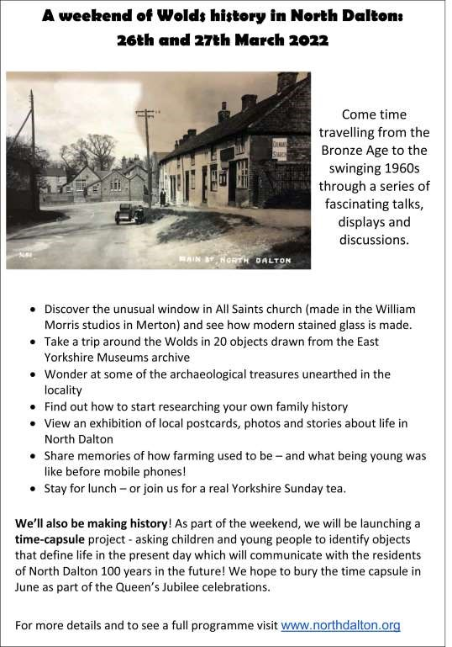

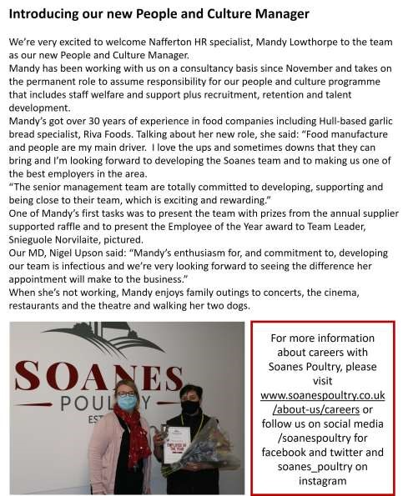
Advertising Feature

Advertisements
Advertisement

Advertising Feature

Regular group activities
Weekly Groups
Monday Pilates 6.00-7.00pm Village Hall
Tuesday YCA 2.00-2.40pm ZoomFriday
Tuesday Tai Chi (from 8th) 2.30-4.00pm Village Hall
Wednesday Line Dancing 7.30-9.00pm Village Hall Thursday Middleton Movers 2.00-3.30pm Village Hall

March
1 Village Hall Committee 2.30pm Village Hall
- Parish Council 7.00pm Reading Rooms
- Book Group 10.30am Village Hall 13 Litter Picking Wombles 10.00am Lime View
17 YCA 7.30pm Village Hall
LOCAL CONTACTS Bell Ringing Chris Atkin |  | 217285
Book Group/Middleton Movers | Lyn Dennis | 219500
Bowls Club | Rob Bradley | 217435
Country Women’s Association | Christine Johnson | 217374
First Responders | Chris Brent | 219469
Line Dancing | Pat Pottage | 217516
Methodist Chapel | Jane Gray | 07870 562455
Middleton Messenger | Mike Kelly | 07713 620912
 | Lyn Dennis | 219500
 | Tina Walker | 217242
Middleton Womblers | Andrew Naylor | 219072
Parish Clerk | Sandra Morrison | 01262 470496
Pilates | Ian Stephenson | 07973 755717
Reading Rooms | Kath Bentley | 217456
Recreation Club | Dave Newlove | 07901 833784
St Andrew’s Church | Rev Jane Anderson | 219471
St Andrew’s Church Warden | Roger Lowe | 217656
Table Tennis | Louise Newlove | 217801
Village Hall | Lyn Dennis | 219500
Village History | Geoff Wisher | 217517
email: middletonflyer@yahoo.com page 28

